**Prima esecuzione, nessun miglioramento, con possibile overfitting**

> ann_training

cnt = 60000

nel = 60000

cnt = 10000

nel = 10000

ans =

0 1 2 3 4 5 6 7 8 9

0 1 2 3 4 5 6 7 8 9

ans = 0.42961

1.00000 72.30298 0.24405 0.25210

2.00000 92.14019 0.18822 0.19960

3.00000 82.72928 0.17025 0.18290

4.00000 84.34682 0.16023 0.17340

5.00000 82.31726 0.15403 0.16810

6.00000 82.44095 0.14942 0.16400

7.00000 82.42703 0.14520 0.16080

8.00000 79.67667 0.14155 0.15740

9.00000 76.10190 0.13855 0.15520

10.00000 82.41132 0.13627 0.15260

11.00000 82.20976 0.13363 0.15050

12.00000 82.39757 0.13178 0.14890

13.00000 87.19502 0.12972 0.14760

14.00000 87.30137 0.12797 0.14590

15.00000 85.08763 0.12655 0.14510

16.00000 82.02420 0.12500 0.14290

17.00000 81.72529 0.12318 0.14100

18.00000 83.90282 0.12177 0.13960

19.00000 84.99216 0.12055 0.13820

20.00000 83.22143 0.11922 0.13700

21.00000 91.57448 0.11782 0.13550

22.00000 83.45134 0.11652 0.13440

23.00000 80.76981 0.11532 0.13360

24.00000 55.14413 0.11428 0.13210

25.00000 79.21778 0.11367 0.13100

26.00000 82.58851 0.11310 0.13110

27.00000 83.29725 0.11223 0.13010

28.00000 83.09324 0.11130 0.12950

29.00000 87.50587 0.11055 0.12930

30.00000 85.18465 0.10972 0.12830

31.00000 83.45265 0.10863 0.12870

32.00000 82.04972 0.10790 0.12850

33.00000 83.71652 0.10682 0.12820

34.00000 76.14625 0.10585 0.12760

35.00000 72.88949 0.10513 0.12730

36.00000 83.27175 0.10450 0.12730

37.00000 83.60129 0.10343 0.12670

38.00000 83.94312 0.10257 0.12600

39.00000 83.83467 0.10158 0.12570

40.00000 86.62796 0.10108 0.12510

41.00000 83.37892 0.10033 0.12480

42.000000 83.380579 0.099733 0.124300

43.000000 88.401082 0.099217 0.124300

44.000000 84.435162 0.098533 0.124100

45.000000 87.960891 0.097833 0.123300

46.000000 69.057055 0.097233 0.122800

47.000000 64.640773 0.096683 0.122600

48.000000 90.985623 0.095983 0.122700

49.000000 87.026328 0.095450 0.122800

50.000000 82.572730 0.094850 0.122400

x =

Columns 1 through 19:

1 2 3 4 5 6 7 8 9 10 11 12 13 14 15 16 17 18 19

Columns 20 through 38:

20 21 22 23 24 25 26 27 28 29 30 31 32 33 34 35 36 37 38

Columns 39 through 50:

39 40 41 42 43 44 45 46 47 48 49 50

when=

0

Acc 90.515 87.76

cfmx =

|  |  |  |  |  |  |  |  |  |  |
| --- | --- | --- | --- | --- | --- | --- | --- | --- | --- |
| 852 | 0 | 18 | 38 | 8 | 2 | 69 | 0 | 13 | 0 |
| 4 | 960 | 2 | 25 | 4 | 0 | 4 | 0 | 1 | 0 |
| 20 | 1 | 804 | 13 | 102 | 0 | 57 | 0 | 3 | 0 |
| 24 | 11 | 12 | 900 | 33 | 0 | 17 | 0 | 3 | 0 |
| 0 | 0 | 89 | 38 | 823 | 1 | 42 | 0 | 7 | 0 |
| 0 | 0 | 0 | 1 | 0 | 935 | 0 | 42 | 2 | 20 |
| 140 | 0 | 97 | 40 | 81 | 0 | 623 | 0 | 19 | 0 |
| 0 | 0 | 0 | 0 | 0 | 22 | 0 | 951 | 0 | 27 |
| 1 | 1 | 5 | 6 | 5 | 2 | 6 | 4 | 970 | 0 |
| 0 | 0 | 0 | 0 | 0 | 5 | 0 | 36 | 1 | 958 |

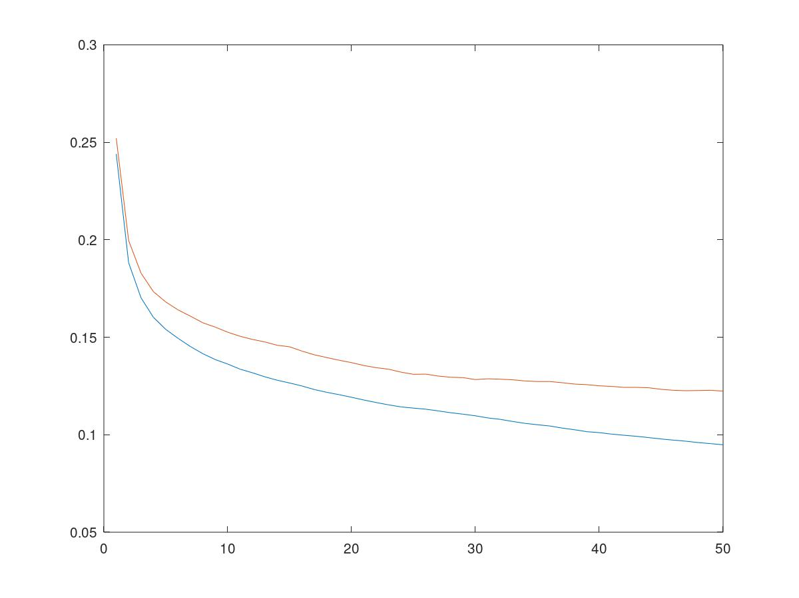

**SECONDO ESPRIMENTO RIDUCO NEURONI E AUMENTO LEARNING**

**noHiddenNeurons = 90;**

**noEpochs = 50;**

**learningRate = 0.002;**

**numberClasses= 10;**

**HAD MORE OVERFITTING**

**ann_training**

**cnt = 60000**

**nel = 60000**

**cnt = 10000**

**nel = 10000**

**ans =**

**0 1 2 3 4 5 6 7 8 9**

**0 1 2 3 4 5 6 7 8 9**

**ans = 0.42961**

**1.00000 55.70164 0.19440 0.20430**

**2.00000 67.90918 0.16297 0.17660**

**3.00000 74.60684 0.15145 0.16560**

**4.00000 74.39449 0.14358 0.15920**

**5.00000 75.92444 0.13755 0.15530**

**6.00000 73.73569 0.13320 0.15040**

**7.00000 71.80562 0.12945 0.14620**

**8.00000 77.63648 0.12645 0.14480**

**9.00000 77.61854 0.12382 0.14330**

**10.00000 82.42102 0.12097 0.14090**

**11.00000 79.84623 0.11868 0.13740**

**12.00000 83.77384 0.11662 0.13640**

**13.00000 84.85402 0.11515 0.13510**

**14.00000 83.07060 0.11355 0.13370**

**15.00000 83.22519 0.11215 0.13300**

**16.00000 84.05211 0.11037 0.13210**

**17.00000 72.85883 0.10947 0.13110**

**18.00000 84.62440 0.10805 0.13040**

**19.00000 87.85304 0.10675 0.12950**

**20.00000 84.00974 0.10537 0.12820**

**21.00000 86.06622 0.10430 0.12760**

**22.00000 85.82609 0.10298 0.12660**

**23.00000 87.09454 0.10182 0.12600**

**24.00000 82.53115 0.10108 0.12640**

**25.000000 79.803423 0.099983 0.126400**

**26.000000 80.105036 0.098883 0.126800**

**27.000000 80.171035 0.097733 0.126700**

**28.000000 89.299853 0.096983 0.126700**

**29.000000 91.364978 0.095967 0.125100**

**30.000000 84.501211 0.094917 0.124000**

**31.000000 82.467625 0.093800 0.123600**

**32.000000 79.725260 0.093000 0.123400**

**33.000000 82.418213 0.092117 0.123300**

**34.000000 82.252794 0.091100 0.122900**

**35.000000 88.637781 0.090167 0.122600**

**36.000000 78.306583 0.089417 0.122300**

**37.000000 78.619529 0.088633 0.122400**

**38.000000 78.524572 0.087850 0.121600**

**39.000000 78.785035 0.087133 0.121400**

**40.000000 69.565744 0.086417 0.121100**

**41.000000 80.830003 0.085467 0.120900**

**42.000000 80.736284 0.084717 0.120700**

**43.000000 79.853179 0.083933 0.120500**

**44.000000 80.815664 0.083317 0.120500**

**45.000000 79.321185 0.082533 0.120600**

**46.000000 86.561723 0.081983 0.120000**

**47.000000 80.349927 0.081400 0.120200**

**48.000000 78.589615 0.080850 0.120500**

**49.000000 79.507763 0.080300 0.119900**

**50.000000 79.114349 0.079733 0.120000**

**x =**

**Columns 1 through 19:**

**Columns 1 through 19:**

**1 2 3 4 5 6 7 8 9 10 11 12 13 14 15 16 17 18 19**

**Columns 20 through 38:**

**20 21 22 23 24 25 26 27 28 29 30 31 32 33 34 35 36 37 38**

**Columns 39 through 50:**

**39 40 41 42 43 44 45 46 47 48 49 50**

**when=**

**0**

**cfmx =**

|  |  |  |  |  |  |  |  |  |  |
| --- | --- | --- | --- | --- | --- | --- | --- | --- | --- |
| 849 | 1 | 21 | 31 | 3 | 2 | 80 | 0 | 13 | 0 |
| 4 | 966 | 3 | 21 | 3 | 0 | 2 | 0 | 1 | 0 |
| 17 | 0 | 809 | 15 | 102 | 0 | 54 | 0 | 3 | 0 |
| 23 | 6 | 12 | 898 | 35 | 0 | 23 | 0 | 3 | 0 |
| 0 | 2 | 86 | 42 | 815 | 1 | 49 | 0 | 5 | 0 |
| 0 | 0 | 0 | 2 | 0 | 934 | 0 | 37 | 2 | 25 |
| 144 | 1 | 83 | 33 | 81 | 0 | 639 | 0 | 19 | 0 |
| 0 | 0 | 0 | 0 | 0 | 15 | 0 | 962 | 0 | 23 |
| 3 | 1 | 3 | 5 | 5 | 1 | 6 | 5 | 971 | 0 |
| 0 | 0 | 0 | 0 | 0 | 3 | 0 | 39 | 1 | 957 |

**TERZO ESPERIMENTO nessun Miglioramento**

**noHiddenNeurons = 130;**

**noEpochs = 50;**

**learningRate = 0.001;**

**numberClasses= 10;**

**cnt = 60000**

**nel = 60000**

**cnt = 10000**

**nel = 10000**

**ans =**

**0 1 2 3 4 5 6 7 8 9**

**0 1 2 3 4 5 6 7 8 9**

**ans = 0.77682**

**1.00000 86.55764 0.24033 0.24840**

**2.00000 91.25629 0.18652 0.19970**

**3.00000 90.98762 0.16878 0.18030**

**4.00000 91.85471 0.15977 0.17480**

**5.00000 94.08368 0.15365 0.16890**

**6.00000 96.51691 0.14852 0.16470**

**7.00000 99.62499 0.14465 0.16200**

**8.00000 98.70610 0.14142 0.15810**

**9.00000 101.88259 0.13862 0.15500**

**10.00000 99.29627 0.13582 0.15180**

**11.00000 91.22744 0.13332 0.14960**

**12.00000 91.00516 0.13130 0.14830**

**13.00000 91.24854 0.12928 0.14730**

**14.00000 88.57784 0.12780 0.14570**

**15.00000 89.16959 0.12602 0.14430**

**16.00000 88.66491 0.12462 0.14350**

**17.00000 493.57083 0.12332 0.14290**

**18.00000 48.09511 0.12202 0.14080**

**19.00000 53.12646 0.12065 0.13960**

**20.00000 44.42465 0.11947 0.13870**

**21.00000 44.41163 0.11833 0.13730**

**22.00000 44.61724 0.11735 0.13620**

**23.00000 44.20822 0.11617 0.13500**

**24.00000 44.45992 0.11528 0.13390**

**25.00000 43.92357 0.11433 0.13350**

**26.00000 44.16129 0.11335 0.13350**

**27.00000 46.17136 0.11240 0.13270**

**28.00000 48.79139 0.11148 0.13130**

**29.00000 43.95685 0.11070 0.13080**

**30.00000 48.05133 0.10982 0.13080**

**31.00000 52.98550 0.10890 0.13050**

**32.00000 45.38364 0.10810 0.12990**

**33.00000 43.95296 0.10722 0.12920**

**34.00000 43.62405 0.10627 0.12940**

**35.00000 44.80921 0.10563 0.12910**

**36.00000 44.85753 0.10505 0.12870**

**37.00000 44.25532 0.10447 0.12790**

**38.00000 45.06870 0.10387 0.12790**

**39.00000 49.01672 0.10325 0.12680**

**40.00000 48.79137 0.10263 0.12640**

**41.00000 46.95502 0.10217 0.12540**

**42.00000 45.49739 0.10145 0.12490**

**43.00000 44.47057 0.10093 0.12500**

**44.00000 44.27187 0.10072 0.12440**

**45.00000 44.09499 0.10008 0.12380**

**46.000000 44.525102 0.099567 0.123400**

**47.000000 46.626881 0.098950 0.123100**

**48.000000 44.535392 0.098350 0.123500**

**49.000000 48.090041 0.097900 0.123400**

**50.000000 45.795210 0.097150 0.123000**

**Acc**

**x =**

**Columns 1 through 19:**

**1 2 3 4 5 6 7 8 9 10 11 12 13 14 15 16 17 18 19**

**Columns 20 through 38:**

**20 21 22 23 24 25 26 27 28 29 30 31 32 33 34 35 36 37 38**

**Columns 39 through 50:**

**39 40 41 42 43 44 45 46 47 48 49 50**

**when=**

**0**

**cfmx =**

|  |  |  |  |  |  |  |  |  |  |
| --- | --- | --- | --- | --- | --- | --- | --- | --- | --- |
| 845 | 1 | 20 | 39 | 4 | 1 | 75 | 0 | 15 | 0 |
| 4 | 960 | 2 | 25 | 4 | 0 | 4 | 0 | 1 | 0 |
| 16 | 0 | 803 | 14 | 108 | 0 | 52 | 0 | 7 | 0 |
| 25 | 11 | 11 | 897 | 33 | 0 | 18 | 0 | 5 | 0 |
| 0 | 0 | 88 | 41 | 822 | 0 | 44 | 0 | 5 | 0 |
| 0 | 0 | 0 | 2 | 0 | 936 | 0 | 43 | 2 | 17 |
| 150 | 1 | 85 | 38 | 86 | 0 | 623 | 0 | 17 | 0 |
| 0 | 0 | 0 | 0 | 0 | 19 | 0 | 953 | 0 | 28 |
| 1 | 1 | 2 | 4 | 4 | 3 | 6 | 4 | 975 | 0 |
| 0 | 0 | 0 | 0 | 0 | 7 | 0 | 36 | 1 | 956 |

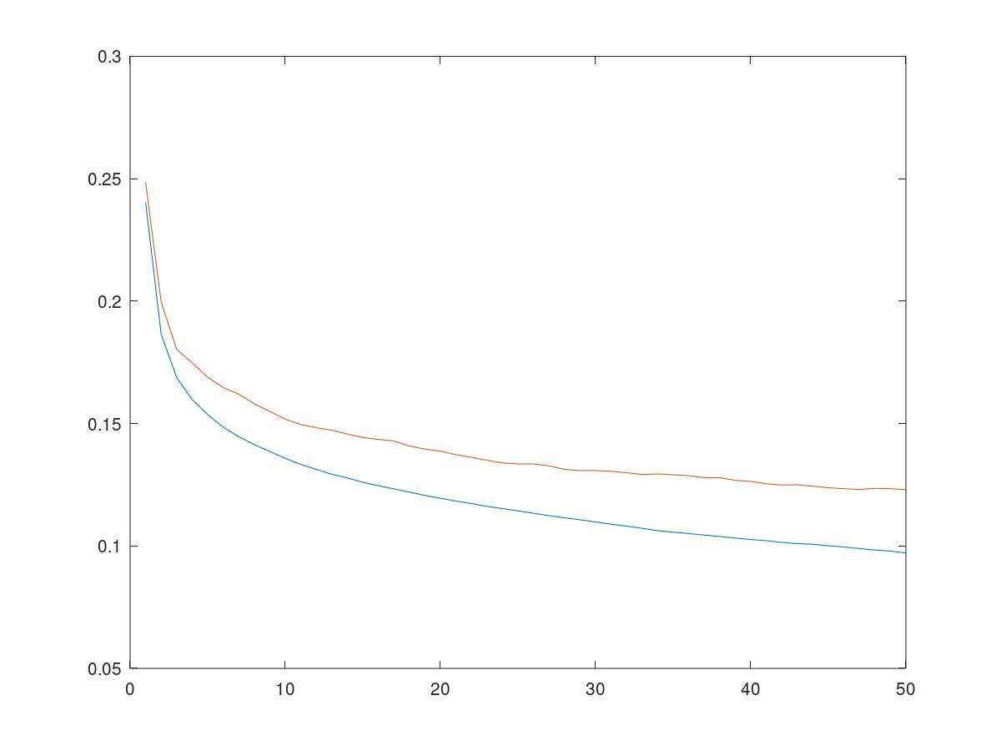

**=======================================================================================**

**=======================================================================================**

**=======================================================================================**

**=======================================================================================**

**=======================================================================================**

**=======================================================================================**

**=======================================================================================**

**TEST 4 CON NORMALIZATION**

**noHiddenNeurons = 100;**

**noEpochs = 50;**

**learningRate = 0.001;**

**numberClasses= 10;**

**cnt = 60000**

**nel = 60000**

**cnt = 10000**

**nel = 10000**

**ans =**

**0 1 2 3 4 5 6 7 8 9**

**0 1 2 3 4 5 6 7 8 9**

**ans = 0.040089**

**1.00000 41.48380 0.15997 0.17140**

**2.00000 38.02390 0.14240 0.16070**

**3.00000 37.97771 0.13275 0.15310**

**4.00000 38.78112 0.12573 0.14700**

**5.00000 38.67915 0.11972 0.14280**

**6.00000 40.96659 0.11542 0.13920**

**7.00000 40.02913 0.11122 0.13690**

**8.00000 40.19866 0.10827 0.13420**

**9.00000 40.39991 0.10500 0.13130**

**10.00000 39.60069 0.10175 0.12970**

**11.000000 42.607094 0.098933 0.128200**

**12.000000 41.452046 0.096667 0.127000**

**13.000000 38.957896 0.093883 0.126600**

**14.000000 39.341320 0.091367 0.125200**

**15.000000 39.690722 0.089200 0.124700**

**16.000000 40.087372 0.087283 0.122400**

**17.000000 39.045686 0.085350 0.122100**

**18.000000 39.185727 0.083583 0.121100**

**19.000000 39.859365 0.081900 0.121300**

**20.000000 39.579275 0.079817 0.121100**

**21.000000 44.094373 0.078150 0.120800**

**22.000000 39.991009 0.076550 0.119900**

**23.000000 39.997330 0.074833 0.120000**

**24.000000 41.038112 0.073333 0.119000**

**25.000000 40.197557 0.071867 0.118900**

**26.000000 42.360861 0.070650 0.118800**

**27.000000 40.841525 0.069433 0.118400**

**28.000000 43.581756 0.068483 0.117700**

**29.000000 40.124888 0.067183 0.116900**

**30.000000 37.995682 0.065850 0.116100**

**31.000000 39.468152 0.064517 0.116300**

**32.000000 38.965110 0.063217 0.116700**

**33.000000 39.031879 0.061967 0.116400**

**34.000000 38.591850 0.061033 0.116100**

**35.000000 39.025550 0.059800 0.115700**

**36.000000 38.618001 0.058733 0.115300**

**37.000000 39.800611 0.057717 0.115400**

**38.000000 39.359050 0.056833 0.114600**

**39.000000 39.427116 0.056033 0.114400**

**40.000000 39.983603 0.055033 0.113800**

**41.000000 40.116899 0.053817 0.113500**

**42.000000 39.647860 0.052917 0.113200**

**43.000000 40.092497 0.051833 0.112900**

**44.000000 39.291666 0.051000 0.112900**

**45.000000 38.874128 0.050000 0.112500**

**46.000000 39.309100 0.049033 0.112400**

**47.000000 38.742839 0.048067 0.112700**

**48.000000 39.736165 0.047467 0.113000**

**49.000000 39.726607 0.046567 0.112600**

**50.000000 39.814735 0.045867 0.111900**

**x =**

**Columns 1 through 19:**

**1 2 3 4 5 6 7 8 9 10 11 12 13 14 15 16 17 18 19**

**Columns 20 through 38:**

**20 21 22 23 24 25 26 27 28 29 30 31 32 33 34 35 36 37 38**

**Columns 39 through 50:**

**39 40 41 42 43 44 45 46 47 48 49 50**

**when=**

**0**

**cfmx =**

|  |  |  |  |  |  |  |  |  |  |
| --- | --- | --- | --- | --- | --- | --- | --- | --- | --- |
| 873 | 1 | 19 | 21 | 6 | 3 | 68 | 1 | 8 | 0 |
| 5 | 965 | 2 | 19 | 3 | 0 | 5 | 0 | 1 | 0 |
| 27 | 1 | 802 | 11 | 98 | 2 | 57 | 1 | 1 | 0 |
| 29 | 7 | 14 | 897 | 27 | 1 | 21 | 0 | 4 | 0 |
| 2 | 1 | 69 | 35 | 828 | 0 | 58 | 1 | 5 | 1 |
| 0 | 0 | 1 | 1 | 0 | 941 | 0 | 29 | 5 | 23 |
| 142 | 1 | 70 | 22 | 70 | 0 | 682 | 0 | 12 | 1 |
| 0 | 0 | 0 | 0 | 0 | 13 | 0 | 965 | 0 | 22 |
| 2 | 0 | 2 | 5 | 7 | 4 | 11 | 2 | 967 | 0 |
| 0 | 0 | 1 | 0 | 0 | 8 | 0 | 30 | 0 | 961 |

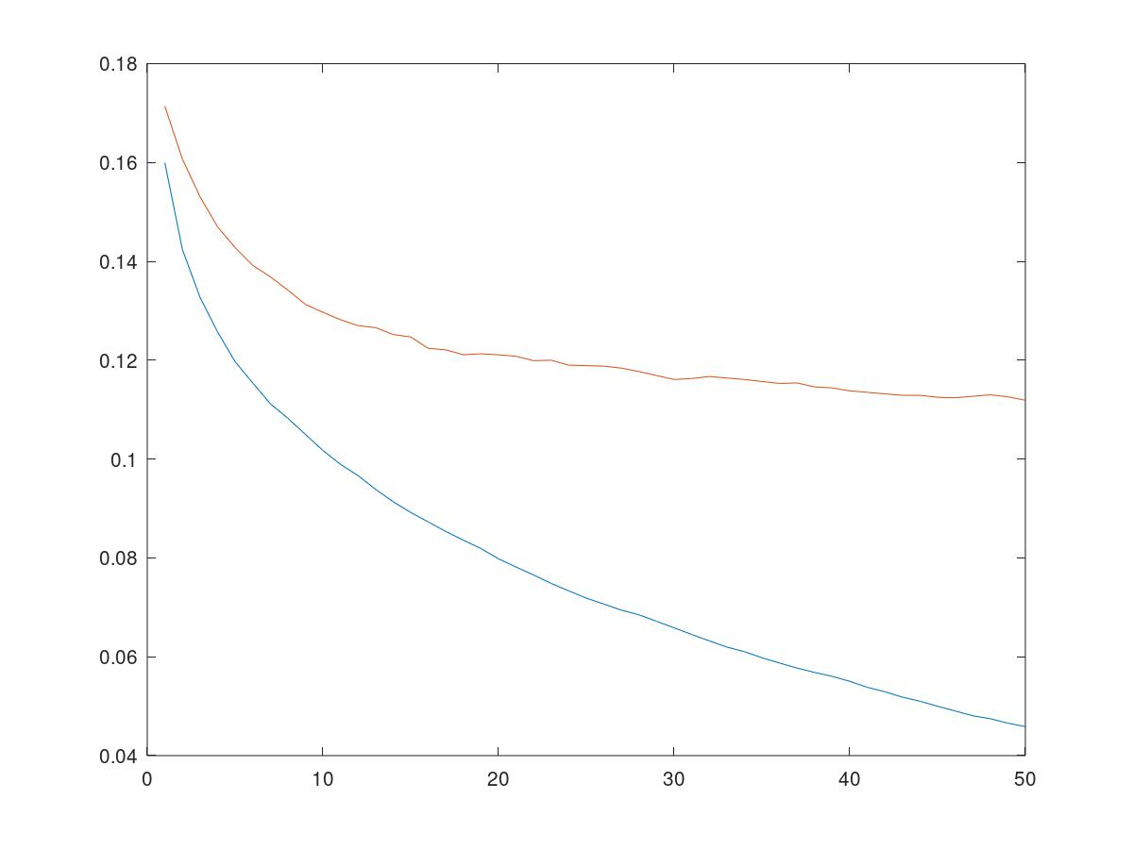

**TEST 5 Normalization + shuffling**

**noHiddenNeurons = 100;**

**noEpochs = 50;**

**learningRate = 0.001;**

**numberClasses= 10;**

**cnt = 60000**

**nel = 60000**

**cnt = 10000**

**nel = 10000**

**ans =**

**0 1 2 3 4 5 6 7 8 9**

**0 1 2 3 4 5 6 7 8 9**

**ans = 0.13354**

**1.00000 83.42389 0.16073 0.17460**

**2.00000 81.85148 0.14303 0.16240**

**3.00000 85.59188 0.13227 0.15140**

**4.00000 84.69391 0.12473 0.14540**

**5.00000 82.42769 0.11973 0.14270**

**6.00000 83.04754 0.11572 0.13890**

**7.00000 83.41755 0.11092 0.13500**

**8.00000 56.70934 0.10795 0.13040**

**9.00000 59.84406 0.10500 0.13290**

**10.00000 77.22702 0.10340 0.13030**

**11.00000 93.91490 0.10092 0.12990**

**12.000000 87.319382 0.096500 0.126900**

**13.000000 88.062993 0.094800 0.125900**

**14.000000 90.435238 0.091500 0.123200**

**15.000000 89.094646 0.089433 0.123800**

**16.000000 91.521089 0.087767 0.123400**

**17.000000 84.765890 0.085250 0.120500**

**18.000000 83.563831 0.082933 0.123200**

**19.000000 82.189241 0.080517 0.120700**

**20.000000 83.163315 0.080233 0.123000**

**21.000000 82.235737 0.076467 0.119200**

**22.000000 83.734127 0.074350 0.118000**

**23.000000 82.681944 0.073400 0.117900**

**24.000000 83.269722 0.071883 0.118400**

**25.000000 83.014136 0.071300 0.117600**

**26.000000 83.286436 0.069250 0.117800**

**27.000000 82.844081 0.068817 0.117000**

**28.000000 90.619613 0.067367 0.117500**

**29.000000 83.618971 0.063433 0.115600**

**30.000000 99.414779 0.062783 0.114300**

**31.000000 96.360082 0.060783 0.114800**

**32.000000 90.635926 0.060650 0.115800**

**33.000000 77.610384 0.059350 0.112300**

**34.000000 76.175679 0.057683 0.113300**

**35.000000 92.766244 0.056967 0.114700**

**36.000000 95.033526 0.055317 0.112200**

**37.000000 91.784906 0.054633 0.113200**

**38.000000 90.965967 0.052600 0.113400**

**39.000000 89.073392 0.052033 0.112800**

**40.000000 91.668049 0.051283 0.111900**

**41.000000 86.749740 0.050583 0.113700**

**42.000000 89.235110 0.051883 0.116100**

**43.000000 90.366582 0.049833 0.114000**

**44.000000 58.428497 0.049467 0.115800**

**45.000000 58.371749 0.047233 0.112600**

**46.000000 56.867730 0.047500 0.114200**

**47.000000 56.585483 0.044483 0.114100**

**48.000000 60.845803 0.045000 0.111700**

**49.000000 42.041867 0.042133 0.111900**

**50.000000 41.694862 0.042833 0.111400**

**x =**

**Columns 1 through 19:**

**1 2 3 4 5 6 7 8 9 10 11 12 13 14 15 16 17 18 19**

**Columns 20 through 38:**

**20 21 22 23 24 25 26 27 28 29 30 31 32 33 34 35 36 37 38**

**Columns 39 through 50:**

**39 40 41 42 43 44 45 46 47 48 49 50**

**when=**

**0**

**cfmx =**

|  |  |  |  |  |  |  |  |  |  |
| --- | --- | --- | --- | --- | --- | --- | --- | --- | --- |
| 864 | 1 | 15 | 25 | 5 | 2 | 79 | 1 | 7 | 1 |
| 5 | 963 | 2 | 19 | 4 | 0 | 6 | 0 | 1 | 0 |
| 22 | 1 | 809 | 15 | 90 | 1 | 58 | 1 | 3 | 0 |
| 24 | 2 | 11 | 897 | 41 | 1 | 20 | 0 | 4 | 0 |
| 0 | 1 | 75 | 23 | 842 | 1 | 51 | 0 | 7 | 0 |
| 0 | 0 | 1 | 1 | 0 | 948 | 0 | 27 | 3 | 20 |
| 128 | 0 | 81 | 32 | 76 | 0 | 671 | 0 | 10 | 2 |
| 0 | 0 | 0 | 0 | 0 | 12 | 0 | 963 | 0 | 25 |
| 3 | 0 | 2 | 6 | 5 | 3 | 7 | 5 | 968 | 1 |
| 0 | 0 | 1 | 0 | 0 | 9 | 0 | 29 | 0 | 961 |

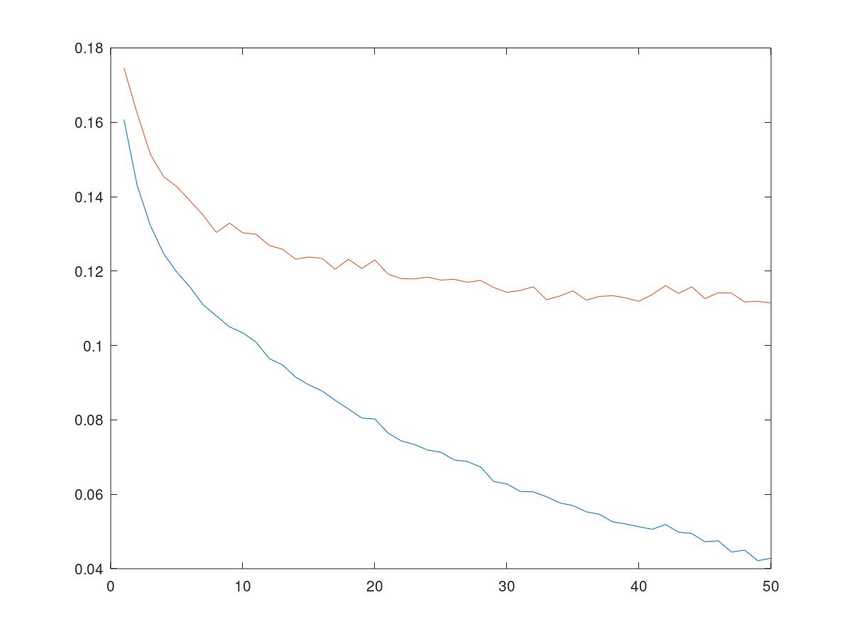

**TEST 5 Normalization + unipolar**

**noHiddenNeurons = 100;**

**noEpochs = 50;**

**learningRate = 0.001;**

**numberClasses= 10;**

**>> ann_training**

**cnt = 60000**

**nel = 60000**

**cnt = 10000**

**nel = 10000**

**ans =**

**0 1 2 3 4 5 6 7 8 9**

**0 1 2 3 4 5 6 7 8 9**

**ans = 0.37471**

**1.00000 73.85343 0.34173 0.34260**

**2.00000 83.02805 0.25632 0.25830**

**3.00000 80.29914 0.22325 0.22940**

**4.00000 81.42448 0.19960 0.20800**

**5.00000 84.38021 0.18482 0.19360**

**6.00000 80.16256 0.17517 0.18650**

**7.00000 71.76862 0.16825 0.18070**

**8.00000 81.86940 0.16243 0.17490**

**9.00000 78.42749 0.15828 0.17060**

**10.00000 81.09888 0.15488 0.16800**

**11.00000 84.30401 0.15193 0.16580**

**12.00000 81.39322 0.14915 0.16440**

**13.00000 81.06646 0.14690 0.16300**

**14.00000 82.51519 0.14427 0.16180**

**15.00000 85.47239 0.14207 0.16100**

**16.00000 88.92383 0.14060 0.15840**

**17.00000 75.04958 0.13887 0.15730**

**18.00000 74.42893 0.13725 0.15620**

**19.00000 84.55850 0.13607 0.15470**

**20.00000 80.70066 0.13435 0.15410**

**21.00000 80.44928 0.13310 0.15370**

**22.00000 81.02950 0.13203 0.15290**

**23.00000 74.75616 0.13105 0.15220**

**24.00000 74.46521 0.13010 0.15220**

**25.00000 74.94937 0.12960 0.15150**

**26.00000 72.22252 0.12882 0.15040**

**27.00000 71.10752 0.12818 0.15000**

**28.00000 71.17308 0.12730 0.14940**

**29.00000 71.44740 0.12660 0.14910**

**30.00000 70.90658 0.12597 0.14850**

**31.00000 244.62167 0.12517 0.14810**

**32.00000 46.10612 0.12422 0.14770**

**33.00000 58.81634 0.12355 0.14720**

**34.00000 89.87416 0.12302 0.14650**

**35.00000 87.96949 0.12260 0.14620**

**36.00000 88.33347 0.12202 0.14560**

**37.00000 81.37077 0.12128 0.14520**

**38.00000 86.84724 0.12078 0.14460**

**39.00000 80.86334 0.12012 0.14410**

**40.00000 86.25536 0.11937 0.14350**

**41.00000 85.76178 0.11885 0.14260**

**42.00000 91.17131 0.11838 0.14200**

**43.00000 93.29439 0.11755 0.14160**

**44.00000 92.04528 0.11703 0.14140**

**45.00000 92.66046 0.11653 0.14110**

**46.00000 91.13026 0.11605 0.14060**

**47.00000 91.15047 0.11560 0.14010**

**48.00000 92.49598 0.11493 0.14020**

**49.00000 90.82586 0.11450 0.14030**

**50.00000 93.50951 0.11415 0.13960**

**x =**

**Columns 1 through 19:**

**1 2 3 4 5 6 7 8 9 10 11 12 13 14 15 16 17 18 19**

**Columns 20 through 38:**

**20 21 22 23 24 25 26 27 28 29 30 31 32 33 34 35 36 37 38**

**Columns 39 through 50:**

**39 40 41 42 43 44 45 46 47 48 49 50**

**when=**

**0**

**Cfmx**

|  |  |  |  |  |  |  |  |  |  |
| --- | --- | --- | --- | --- | --- | --- | --- | --- | --- |
| 828 | 0 | 8 | 71 | 5 | 5 | 71 | 0 | 12 | 0 |
| 5 | 953 | 1 | 31 | 5 | 0 | 3 | 1 | 1 | 0 |
| 17 | 2 | 735 | 24 | 144 | 6 | 67 | 1 | 3 | 1 |
| 18 | 6 | 4 | 924 | 23 | 2 | 19 | 1 | 3 | 0 |
| 0 | 1 | 77 | 52 | 812 | 3 | 50 | 1 | 4 | 0 |
| 0 | 0 | 0 | 2 | 0 | 929 | 0 | 46 | 2 | 21 |
| 148 | 2 | 77 | 79 | 89 | 6 | 584 | 2 | 12 | 1 |
| 0 | 0 | 0 | 0 | 0 | 26 | 0 | 953 | 0 | 21 |
| 3 | 1 | 7 | 10 | 5 | 10 | 7 | 6 | 948 | 3 |
| 0 | 0 | 0 | 0 | 0 | 14 | 1 | 47 | 0 | 938 |

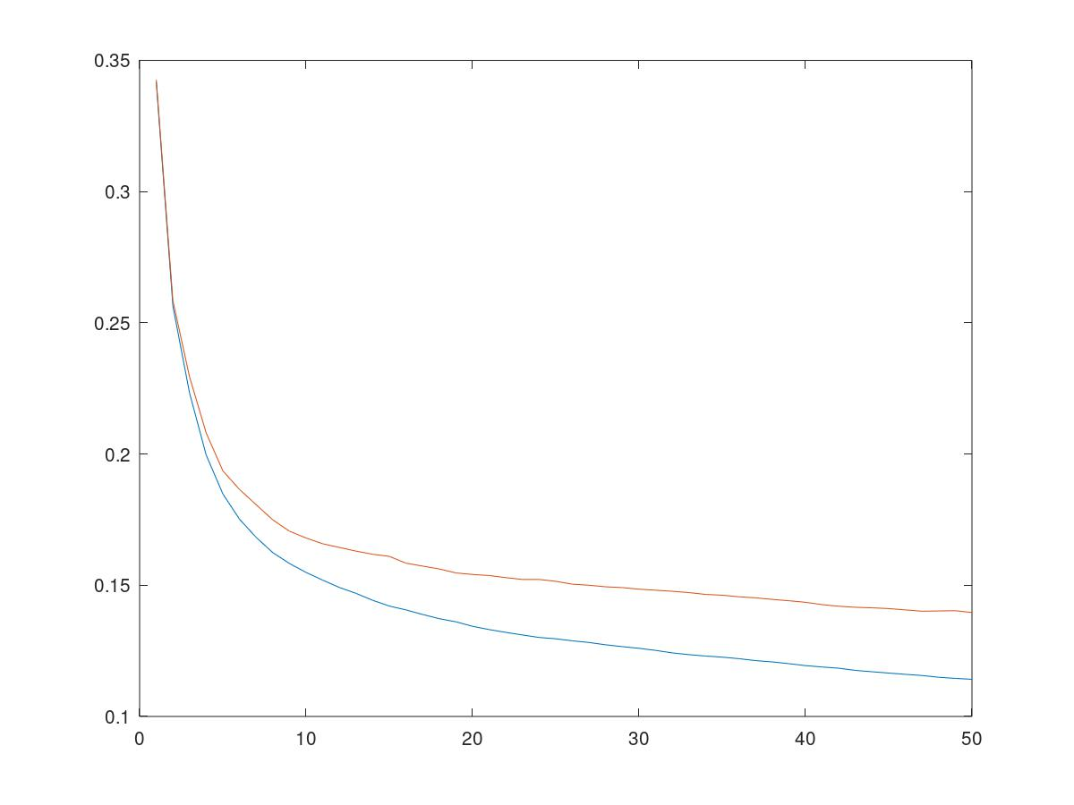

**TEST 6** **BIPOLAR, NORMALIZATION, MOMENTUM ALFA = 1- Lr, no shuffling**

**noHiddenNeurons = 100;**

**noEpochs = 50;**

**learningRate = 0.001;**

**numberClasses= 10;**

**架俑韵즡䜔笼齔ans = 0.54156**

**1.00000 57.14327 0.14570 0.16260**

**2.00000 54.53337 0.12970 0.15010**

**3.00000 67.66257 0.11968 0.14210**

**4.00000 70.66790 0.11237 0.13610**

**5.00000 66.56135 0.10648 0.13250**

**6.00000 63.18848 0.10187 0.12990**

**7.000000 61.489143 0.097150 0.127500**

**8.000000 58.918972 0.093700 0.124900**

**9.000000 57.201874 0.090183 0.123200**

**10.000000 56.181001 0.087083 0.121300**

**11.000000 56.212001 0.083633 0.119800**

**12.000000 55.563058 0.080900 0.117900**

**13.000000 56.694165 0.078250 0.117400**

**14.000000 59.006497 0.075900 0.118300**

**15.000000 57.888448 0.073600 0.117300**

**16.000000 63.382656 0.070867 0.115900**

**17.000000 64.307454 0.068633 0.115100**

**18.000000 66.355058 0.066400 0.114400**

**19.000000 57.397935 0.064200 0.113500**

**20.000000 55.773364 0.062350 0.113300**

**21.000000 55.211225 0.060750 0.113000**

**22.000000 56.093901 0.059267 0.113100**

**23.000000 55.837271 0.057983 0.113000**

**24.000000 56.831424 0.056617 0.113900**

**25.000000 54.992078 0.055650 0.113900**

**26.000000 54.984479 0.054317 0.113700**

**27.000000 59.935321 0.053067 0.112900**

**28.000000 55.137552 0.051917 0.112800**

**29.000000 57.153837 0.050833 0.113100**

**30.000000 57.525950 0.049683 0.113700**

**31.000000 55.224199 0.048633 0.113900**

**32.000000 58.379485 0.047850 0.114000**

**33.000000 60.454119 0.046833 0.113600**

**STOP AFTER 28**

|  |  |  |  |  |  |  |  |  |  |
| --- | --- | --- | --- | --- | --- | --- | --- | --- | --- |
| 872 | 1 | 18 | 19 | 8 | 1 | 68 | 1 | 12 | 0 |
| 7 | 962 | 3 | 18 | 3 | 0 | 6 | 0 | 1 | 0 |
| 21 | 0 | 801 | 10 | 106 | 1 | 59 | 0 | 2 | 0 |
| 29 | 6 | 13 | 905 | 23 | 1 | 18 | 0 | 4 | 1 |
| 1 | 1 | 72 | 34 | 832 | 0 | 56 | 0 | 3 | 1 |
| 0 | 0 | 1 | 1 | 0 | 943 | 0 | 30 | 2 | 23 |
| 150 | 1 | 71 | 28 | 73 | 0 | 666 | 0 | 10 | 1 |
| 0 | 0 | 0 | 0 | 0 | 13 | 0 | 967 | 0 | 20 |
| 4 | 0 | 3 | 5 | 4 | 3 | 10 | 4 | 967 | 0 |
| 0 | 0 | 0 | 1 | 0 | 7 | 1 | 34 | 0 | 957 |

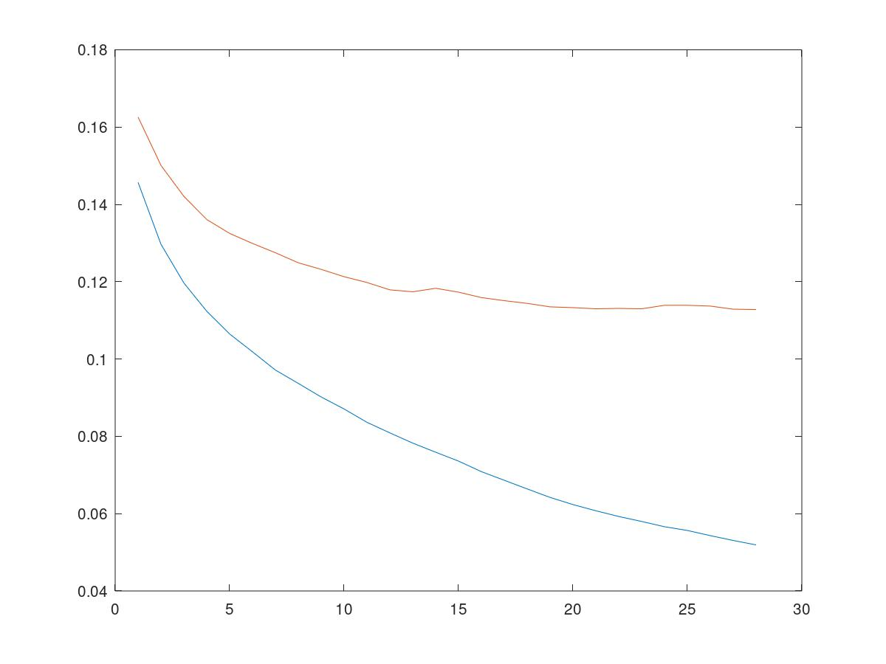

**ADAPTIVE LEARNING RATE, BIPOLAR, NORMALIZATION, MOMENTUM ALFA = 1- Lr, no shuffling**

**Starting 0.003 diminishing 0.0005 per epoch**

**筐韔learningRate = 0.0026500**

**8.000000 57.449999 0.079250 0.123100**

**learningRate = 0.0026000**

**9.000000 61.809924 0.077233 0.122000**

**learningRate = 0.0025500**

**10.000000 58.772121 0.074867 0.122200**

**learningRate = 0.0025000**

**11.000000 57.175426 0.072217 0.120800**

**learningRate = 0.0024500**

**12.000000 58.192265 0.069417 0.120800**

**learningRate = 0.0024000**

**13.000000 59.171057 0.067133 0.119500**

**learningRate = 0.0023500**

**14.000000 69.192727 0.063983 0.118700**

**learningRate = 0.0023000**

**15.000000 62.450682 0.061933 0.119500**

**learningRate = 0.0022500**

**16.000000 61.605631 0.059150 0.118500**

**learningRate = 0.0022000**

**17.000000 62.877577 0.057333 0.118400**

**learningRate = 0.0021500**

**18.000000 60.778699 0.055400 0.117300**

**learningRate = 0.0021000**

**19.000000 55.614649 0.053683 0.116800**

**learningRate = 0.0020500**

**20.000000 57.279981 0.052817 0.117100**

**learningRate = 0.0020000**

**21.000000 54.774409 0.052267 0.117300**

**learningRate = 0.0019500**

**22.000000 53.848759 0.051600 0.118300**

**learningRate = 0.0019000**

**23.000000 55.795989 0.050983 0.119000**

**learningRate = 0.0018500**

**24.000000 61.296520 0.050400 0.119300**

**learningRate = 0.0018000**

**ERALY STOPPING**

|  |  |  |  |  |  |  |  |  |  |
| --- | --- | --- | --- | --- | --- | --- | --- | --- | --- |
| 872 | 2 | 10 | 27 | 7 | 1 | 70 | 1 | 10 | 0 |
| 3 | 968 | 1 | 19 | 3 | 0 | 4 | 0 | 2 | 0 |
| 28 | 0 | 769 | 12 | 109 | 1 | 77 | 2 | 2 | 0 |
| 24 | 4 | 12 | 904 | 30 | 2 | 18 | 2 | 4 | 0 |
| 3 | 2 | 74 | 29 | 829 | 2 | 58 | 0 | 3 | 0 |
| 1 | 0 | 1 | 1 | 0 | 936 | 0 | 33 | 2 | 26 |
| 148 | 7 | 64 | 35 | 63 | 0 | 669 | 0 | 12 | 2 |
| 0 | 0 | 0 | 0 | 0 | 11 | 0 | 973 | 0 | 16 |
| 2 | 0 | 6 | 6 | 3 | 4 | 9 | 3 | 967 | 0 |
| 0 | 0 | 0 | 0 | 0 | 6 | 2 | 47 | 0 | 945 |

**DUE LAYER**

**MIA**

**1.00000 69.29625 0.20703 0.21360**

**2.00000 67.94051 0.17727 0.18840**

**3.00000 59.26337 0.16697 0.17890**

**4.00000 60.71672 0.16228 0.17430**

**5.00000 55.52325 0.15878 0.17310**

**6.00000 53.47845 0.15685 0.17120**

**7.00000 53.58917 0.15487 0.16980**

**8.00000 53.66029 0.15338 0.16950**

**9.00000 53.39586 0.15227 0.16840**

**10.00000 53.27595 0.15142 0.16750**

**11.00000 51.55762 0.15055 0.16720**

**12.00000 51.40615 0.14970 0.16660**

**13.00000 51.32914 0.14928 0.16560**

**14.00000 55.12410 0.14883 0.16500**

**15.00000 54.69217 0.14812 0.16480**

**16.00000 52.73056 0.14772 0.16480**

**17.00000 52.00920 0.14717 0.16480**

**18.00000 52.26138 0.14675 0.16470**

**19.00000 52.89370 0.14625 0.16460**

**20.00000 53.03461 0.14622 0.16430**

**21.00000 51.63060 0.14602 0.16370**

**22.00000 52.36032 0.14595 0.16340**

**23.00000 62.20820 0.14567 0.16350**

**24.00000 68.51450 0.14540 0.16280**

**25.00000 67.13527 0.14528 0.16240**

**26.00000 65.90343 0.14537 0.16230**

**27.00000 59.97992 0.14513 0.16240**

**28.00000 63.10569 0.14498 0.16240**

**29.00000 61.11532 0.14487 0.16230**

**30.00000 64.47923 0.14475 0.16250**

**31.00000 61.95007 0.14457 0.16260**

**32.00000 56.75911 0.14448 0.16250**

**33.00000 61.85448 0.14430 0.16260**

**34.00000 61.47972 0.14430 0.16230**

**35.00000 58.36733 0.14422 0.16230**

**36.00000 61.68647 0.14407 0.16220**

**37.00000 64.34799 0.14393 0.16240**

**38.00000 58.95979 0.14373 0.16250**

**39.00000 69.83805 0.14370 0.16250**

**40.00000 61.73330 0.14365 0.16220**

**41.00000 60.07656 0.14357 0.16230**

**42.00000 67.35373 0.14347 0.16230**

**43.00000 68.37313 0.14342 0.16220**

**44.00000 67.42206 0.14325 0.16200**

**45.00000 64.11339 0.14310 0.16190**

**46.00000 65.32185 0.14300 0.16150**

**47.00000 72.73408 0.14283 0.16130**

**48.00000 66.19879 0.14285 0.16120**

**49.00000 65.91356 0.14277 0.16120**

**50.00000 63.00151** **0.14265 0.16140**

|  |  |  |  |  |  |  |  |  |  |
| --- | --- | --- | --- | --- | --- | --- | --- | --- | --- |
| 825 | 0 | 17 | 80 | 5 | 2 | 52 | 0 | 19 | 0 |
| 4 | 943 | 5 | 37 | 5 | 0 | 3 | 1 | 2 | 0 |
| 23 | 1 | 755 | 15 | 151 | 2 | 46 | 0 | 7 | 0 |
| 26 | 7 | 20 | 887 | 33 | 1 | 20 | 0 | 5 | 1 |
| 1 | 0 | 95 | 47 | 794 | 1 | 53 | 1 | 7 | 1 |
| 0 | 0 | 0 | 4 | 0 | 891 | 0 | 66 | 8 | 31 |
| 173 | 3 | 132 | 68 | 116 | 1 | 479 | 0 | 27 | 1 |
| 0 | 0 | 0 | 0 | 0 | 36 | 0 | 930 | 1 | 33 |
| 2 | 2 | 11 | 13 | 4 | 6 | 8 | 4 | 950 | 0 |
| 0 | 0 | 0 | 0 | 0 | 13 | 1 | 54 | 0 | 932 |



**CON MOMENTUM SU DUE LAYER**

**1.00000 103.64031 0.16372 0.17860**

**2.00000 112.06167 0.14900 0.16680**

**3.00000 110.48575 0.14487 0.16310**

**4.00000 110.77695 0.14192 0.16080**

**5.00000 110.13896 0.14103 0.16110**

**6.00000 94.47660 0.13975 0.15990**

**7.00000 108.52060 0.13938 0.15940**

**8.00000 122.46941 0.13903 0.15860**

**9.00000 109.22976 0.13883 0.15900**

**10.00000 100.16550 0.13827 0.15870**

**11.00000 106.13185 0.13803 0.15860**

**12.00000 96.83557 0.13808 0.15800**

**13.00000 97.19374 0.13792 0.15800**

**14.00000 96.99612 0.13755 0.15760**

**15.00000 93.80056 0.13738 0.15740**

**16.00000 96.40057 0.13725 0.15660**

**17.00000 91.14234 0.13720 0.15660**

**18.00000 96.01584 0.13712 0.15660**

**19.00000 89.70796 0.13720 0.15670**

**20.00000 84.11019 0.13733 0.15630**

**21.00000 90.73249 0.13717 0.15650**

**22.00000 84.10945 0.13700 0.15630**

**23.00000 78.78018 0.13685 0.15630**

**24.00000 82.22227 0.13672 0.15590**

**25.00000 83.66711 0.13665 0.15590**

**26.00000 81.92707 0.13652 0.15580**

**27.00000 87.84148 0.13638 0.15580**

**28.00000 92.28538 0.13630 0.15580**

**29.00000 87.47950 0.13607 0.15550**

**30.00000 86.58081 0.13598 0.15570**

**31.00000 92.60944 0.13585 0.15580**

**32.00000 87.32944 0.13582 0.15580**

**33.00000 80.65899 0.13568 0.15540**

**34.00000 83.51344 0.13572 0.15510**

**35.00000 85.85716 0.13568 0.15480**

**36.00000 83.63889 0.13567 0.15510**

**37.00000 85.75222 0.13553 0.15480**

**38.00000 77.81586 0.13542 0.15470**

**39.00000 70.93562 0.13547 0.15480**

**40.00000 74.77737 0.13543 0.15480**

**41.00000 71.63421 0.13540 0.15480**

**42.00000 71.24083 0.13545 0.15510**

**43.00000 71.06124 0.13547 0.15450**

**44.00000 70.95963 0.13552 0.15470**

**45.00000 70.77841 0.13560 0.15450**

**46.00000 77.11957 0.13547 0.15450**

**47.00000 77.85972 0.13543 0.15470**

**48.00000 89.21141 0.13532 0.15450**

**49.00000 87.32174 0.13533 0.15450**

**50.00000 81.20600 0.13535 0.15450**

|  |  |  |  |  |  |  |  |  |  |
| --- | --- | --- | --- | --- | --- | --- | --- | --- | --- |
| 824 | 1 | 17 | 81 | 6 | 2 | 54 | 0 | 15 | 0 |
| 4 | 949 | 3 | 35 | 4 | 0 | 3 | 0 | 2 | 0 |
| 19 | 1 | 770 | 14 | 145 | 1 | 40 | 0 | 10 | 0 |
| 24 | 6 | 15 | 902 | 31 | 1 | 17 | 0 | 4 | 0 |
| 0 | 1 | 102 | 44 | 805 | 0 | 39 | 1 | 7 | 1 |
| 0 | 0 | 0 | 3 | 0 | 901 | 0 | 61 | 7 | 28 |
| 166 | 3 | 126 | 70 | 118 | 0 | 481 | 1 | 34 | 1 |
| 0 | 0 | 0 | 0 | 0 | 30 | 0 | 947 | 1 | 22 |
| 1 | 3 | 9 | 13 | 6 | 6 | 4 | 5 | 953 | 0 |
| 0 | 0 | 0 | 0 | 0 | 13 | 0 | 63 | 1 | 923 |

|  |  |  |  |  |  |  |  |  |  |
| --- | --- | --- | --- | --- | --- | --- | --- | --- | --- |
| 825 | 0 | 17 | 80 | 5 | 2 | 52 | 0 | 19 | 0 |
| 4 | 943 | 5 | 37 | 5 | 0 | 3 | 1 | 2 | 0 |
| 23 | 1 | 755 | 15 | 151 | 2 | 46 | 0 | 7 | 0 |
| 26 | 7 | 20 | 887 | 33 | 1 | 20 | 0 | 5 | 1 |
| 1 | 0 | 95 | 47 | 794 | 1 | 53 | 1 | 7 | 1 |
| 0 | 0 | 0 | 4 | 0 | 891 | 0 | 66 | 8 | 31 |
| 173 | 3 | 132 | 68 | 116 | 1 | 479 | 0 | 27 | 1 |
| 0 | 0 | 0 | 0 | 0 | 36 | 0 | 930 | 1 | 33 |
| 2 | 2 | 11 | 13 | 4 | 6 | 8 | 4 | 950 | 0 |
| 0 | 0 | 0 | 0 | 0 | 13 | 1 | 54 | 0 | 932 |